**PROJECT TITLE:** Image Cartoonization

**TEAM ID:** 4039

**TEAM LEADER:** Afsinbanu Saeed

**TEAM MEMBERS**: Mariya Tohfafarosh

Ansh Shah

Avneet Kashyap

**TEAM LEADER EMAIL ID:** [afsin.saeed@gmail.com](mailto:afsin.saeed@gmail.com)

**INSTITUTE NAME:** Sarvajanik College of Engineering & Technology

**DEPARTMENT:** 1. Electrical 2. Instrumentation and Control

**ABSTRACT:**

This document represents a technique of converting image to cartoon. Using the mentioned technique it is possible to convert all types of captured images to cartoon such as images of person, mountains, trees, flora and fauna etc. There are several other techniques for image to cartoon conversion such as using Photoshop, adobe illustrator, windows MAC, paint.net and much more.

**INTRODUCTION:**

Creating a cartoon like effect is time and space consuming. Existing solutions to provide cartoon like effect to images are complex. Some solutions involve installing complex photo editing software like Photoshop and other involve performing some task by user.

Proposed solution:

An algorithm of machine learning and code written in python which have simple user interface allowing users to apply the cartoon filters to images of their choice. The goal is to solely remove/significantly decrease the noise and get helpful image structures.

**BLOCK DIAGRAM:**

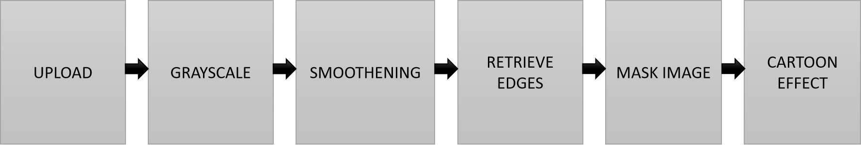

**TECHNOLOGIES USED:**

1. Programming language: Python
2. Libraries: cv2, numpy, matplotlib
3. Algorithm/Techniques used:

* Color Quantization/Vector Quantization

It is an image processing technique that reduces the number of colors to show the image while preserving the overall appearance quality. It basically uses the K-Means clustering method to perform the task. K-means clustering is a method of finding a group of data. Each group is called a cluster.

*K-means clustering algorithm*

It is an iterative algorithm that divides the unlabeled dataset into k different clusters in such a way that each dataset belongs only one group that has similar properties.

It is a centroid-based algorithm, where each cluster is associated with a centroid. The main aim of this algorithm is to minimize the sum of distances between the data point and their corresponding clusters.

The k-means clustering algorithm mainly performs two tasks:

-Determines the best value for K center points or centroids by an iterative process.

-Assigns each data point to its closest k-center. Those data points which are near to the particular k-center, create a cluster.

Hence each cluster has datapoints with some commonalities, and it is away from other clusters.

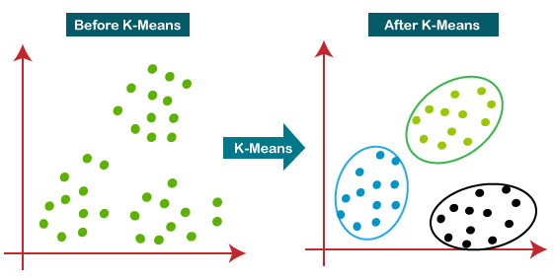

* Adaptive threshold

Thresholding is an image segmentation technique by setting all pixels whose values are above the threshold as foreground and the rest of the pixels as background. But in adaptive thresholding, these values are calculated for smaller regions.So we get different thresholds for different regions of the same image which gives better results for images with varying illumination.

In addition to the parameters described above, the method cv.adaptiveThreshold takes three input parameters:

The adaptiveMethod decides how the threshold value is calculated:

-cv.ADAPTIVE_THRESH_MEAN_C: The threshold value is the mean of the neighbourhood area minus the constant C.

-cv.ADAPTIVE_THRESH_GAUSSIAN_C: The threshold value is a gaussian-weighted sum of the neighbourhood values minus the constant C.

-The blockSize determines the size of the neighbourhood area and C is a constant that is subtracted from the mean or weighted sum of the neighbourhood pixels.

1. Platform: Jupyter Notebook

**RESULT:**

Input image

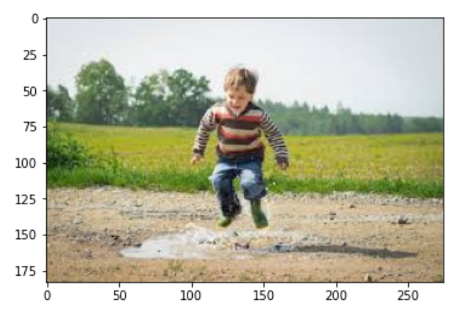

Edge detection and gray scaling

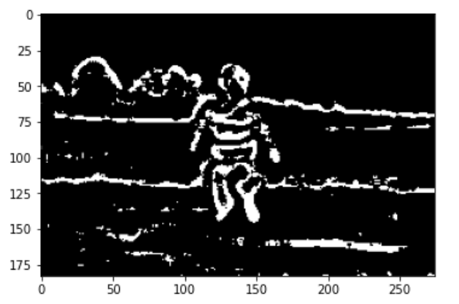

Removal of colour and Smoothening

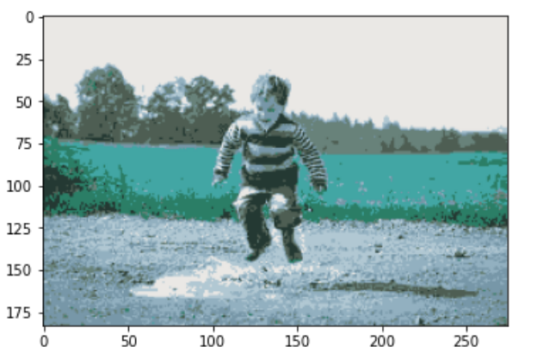

Final output

